RECYCLE VIEW

Create an xml resource file named **listrow.xml** and add below code  
*<?***xml version="1.0" encoding="utf-8"***?>*<**RelativeLayout xmlns:android="http://schemas.android.com/apk/res/android"  
 android:layout_width="match_parent"  
 android:layout_height="wrap_content"  
 android:focusable="true"  
 android:paddingLeft="16dp"  
 android:paddingRight="16dp"  
 android:paddingTop="10dp"  
 android:paddingBottom="10dp"  
 android:clickable="true"  
 android:background="?android:attr/selectableItemBackground"  
 android:orientation="vertical"**>  
  
 <**TextView  
 android:id="@+id/title"  
 android:textColor="#000"  
 android:textSize="16dp"  
 android:textStyle="bold"  
 android:layout_alignParentTop="true"  
 android:layout_width="match_parent"  
 android:layout_height="wrap_content"** />  
  
 <**TextView  
 android:id="@+id/genre"  
 android:layout_below="@id/title"  
 android:layout_width="match_parent"  
 android:layout_height="wrap_content"** />  
  
 <**TextView  
 android:id="@+id/year"  
 android:textColor="#000"  
 android:layout_width="wrap_content"  
 android:layout_alignParentRight="true"  
 android:layout_height="wrap_content"** />  
  
</**RelativeLayout**>

Create a class Named **listvalues.java** andpaste below code

**package** in.nic.kerala.training;  
**public class** listvalues {  
 **private** String **title**, **genre**, **year**;  
  
 **public** listvalues() {  
 }  
  
 **public** listvalues(String title, String genre, String year) {  
 **this**.**title** = title;  
 **this**.**genre** = genre;  
 **this**.**year** = year;  
 }  
  
 **public** String getTitle() {  
 **return title**;  
 }  
  
 **public void** setTitle(String title) {  
 **this**.**title** = title;  
 }  
  
 **public** String getGenre() {  
 **return genre**;  
 }  
  
 **public void** setGenre(String genre) {  
 **this**.**genre** = genre;  
 }  
  
 **public** String getYear() {  
 **return year**;  
 }  
  
 **public void** setYear(String year) {  
 **this**.**year** = year;  
 }  
}

Create a class Named **listadapter.java** and paste below code  
  
**package** in.nic.kerala.training;  
**import** android.support.v7.widget.RecyclerView;  
**import** android.view.LayoutInflater;  
**import** android.view.View;  
**import** android.view.ViewGroup;  
**import** android.widget.TextView;  
  
**import** java.util.List;  
**public class** listadapter **extends** RecyclerView.Adapter<listadapter.MyViewHolder>{  
  
  
 **private** List<listvalues> **moviesList**;  
  
 **public class** MyViewHolder **extends** RecyclerView.ViewHolder {  
 **public** TextView **title**, **year**, **genre**;  
  
 **public** MyViewHolder(View itemView) {  
 **super**(itemView);  
 **title** = (TextView) itemView.findViewById(R.id.***title***);  
 **genre** = (TextView) itemView.findViewById(R.id.***genre***);  
 **year** = (TextView) itemView.findViewById(R.id.***year***);  
 }  
 }  
 **public** listadapter(List<listvalues> moviesList) {  
 **this**.**moviesList** = moviesList;  
 }  
  
 @Override  
 **public** MyViewHolder onCreateViewHolder(ViewGroup parent, **int** viewType) {  
 View itemView = LayoutInflater.*from*(parent.getContext())  
 .inflate(R.layout.***listrow***, parent, **false**);  
 **return new** MyViewHolder(itemView);  
 }  
  
 @Override  
 **public void** onBindViewHolder(MyViewHolder holder, **int** position) {  
 listvalues movie = **moviesList**.get(position);  
 holder.**title**.setText(movie.getTitle());  
 holder.**genre**.setText(movie.getGenre());  
 holder.**year**.setText(movie.getYear());  
 }  
 @Override  
 **public int** getItemCount() {  
 **return moviesList**.size();  
 }  
}

Create an activity named **RecyclerViewExampleActivity**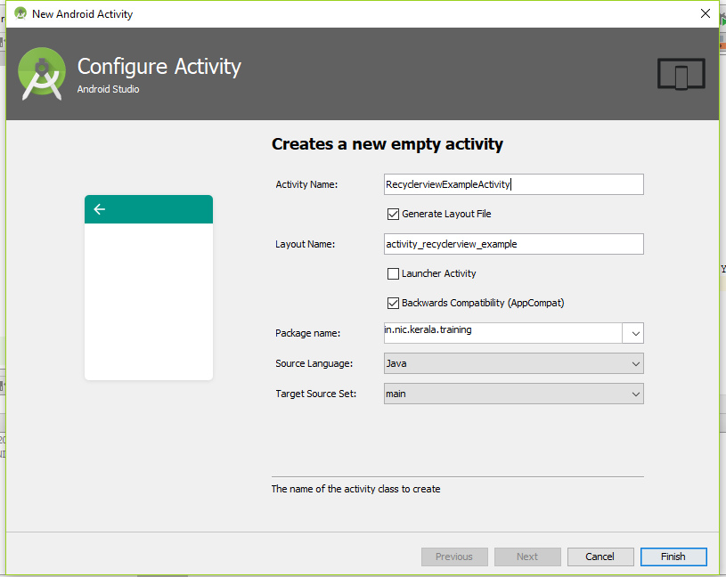

Open **activity_recyclerview_example.xml** and add below code

*<?***xml version="1.0" encoding="utf-8"***?>*<**RelativeLayout  
 xmlns:android="http://schemas.android.com/apk/res/android"  
 xmlns:tools="http://schemas.android.com/tools"  
 xmlns:app="http://schemas.android.com/apk/res-auto"  
 android:layout_width="match_parent"  
 android:layout_height="match_parent"  
 app:layout_behavior="@string/appbar_scrolling_view_behavior"**>  
  
 <**android.support.v7.widget.RecyclerView  
 android:id="@+id/recycler_view"  
 android:layout_width="match_parent"  
 android:layout_height="wrap_content"  
 android:scrollbars="vertical"** />  
</**RelativeLayout**>

Open **RecyclerViewExampleActivity**.**java** and add below code

**package** in.nic.kerala.training;  
**import** android.os.Bundle;  
**import** android.support.v7.app.AppCompatActivity;  
**import** android.support.v7.widget.DefaultItemAnimator;  
**import** android.support.v7.widget.LinearLayoutManager;  
**import** android.support.v7.widget.RecyclerView;  
**import** java.util.ArrayList;  
**import** java.util.List;  
  
**public class** RecyclerviewExampleActivity **extends** AppCompatActivity {  
 **private** List<listvalues> **movieList** = **new** ArrayList<>();  
 **private** RecyclerView **recyclerView**;  
 **private** listadapter **mAdapter**;  
  
 @Override  
 **protected void** onCreate(Bundle savedInstanceState) {  
 **super**.onCreate(savedInstanceState);  
 setContentView(R.layout.***activity_recyclerview_example***);  
 **recyclerView** = (RecyclerView) findViewById(R.id.***recycler_view***);  
 **mAdapter** = **new** listadapter(**movieList**);  
 RecyclerView.LayoutManager mLayoutManager = **new** LinearLayoutManager(getApplicationContext());  
 **recyclerView**.setLayoutManager(mLayoutManager);  
 **recyclerView**.setItemAnimator(**new** DefaultItemAnimator());  
 **recyclerView**.setAdapter(**mAdapter**);  
 prepareMovieData();  
 }  
  
 **private void** prepareMovieData() {  
 listvalues movie = **new** listvalues(**"Mad Max: Fury Road"**, **"Action & Adventure"**, **"2015"**);  
 **movieList**.add(movie);  
  
 movie = **new** listvalues(**"Inside Out"**, **"Animation, Kids & Family"**, **"2015"**);  
 **movieList**.add(movie);  
  
 movie = **new** listvalues(**"Star Wars: Episode VII - The Force Awakens"**, **"Action"**, **"2015"**);  
 **movieList**.add(movie);  
  
 movie = **new** listvalues(**"Shaun the Sheep"**, **"Animation"**, **"2015"**);  
 **movieList**.add(movie);  
  
 movie = **new** listvalues(**"The Martian"**, **"Science Fiction & Fantasy"**, **"2015"**);  
 **movieList**.add(movie);  
  
 movie = **new** listvalues(**"Mission: Impossible Rogue Nation"**, **"Action"**, **"2015"**);  
 **movieList**.add(movie);  
  
 movie = **new** listvalues(**"Up"**, **"Animation"**, **"2009"**);  
 **movieList**.add(movie);  
  
 movie = **new** listvalues(**"Star Trek"**, **"Science Fiction"**, **"2009"**);  
 **movieList**.add(movie);  
  
 movie = **new** listvalues(**"The LEGO Movie"**, **"Animation"**, **"2014"**);  
 **movieList**.add(movie);  
  
 movie = **new** listvalues(**"Iron Man"**, **"Action & Adventure"**, **"2008"**);  
 **movieList**.add(movie);  
  
 movie = **new** listvalues(**"Aliens"**, **"Science Fiction"**, **"1986"**);  
 **movieList**.add(movie);  
  
 movie = **new** listvalues(**"Chicken Run"**, **"Animation"**, **"2000"**);  
 **movieList**.add(movie);  
  
 movie = **new** listvalues(**"Back to the Future"**, **"Science Fiction"**, **"1985"**);  
 **movieList**.add(movie);  
  
 movie = **new** listvalues(**"Raiders of the Lost Ark"**, **"Action & Adventure"**, **"1981"**);  
 **movieList**.add(movie);  
  
 movie = **new** listvalues(**"Goldfinger"**, **"Action & Adventure"**, **"1965"**);  
 **movieList**.add(movie);  
  
 movie = **new** listvalues(**"Guardians of the Galaxy"**, **"Science Fiction & Fantasy"**, **"2014"**);  
 **movieList**.add(movie);  
  
 **mAdapter**.notifyDataSetChanged();  
 }  
}